**CSS Text**

1. Which property is used to change text color? Which ways can you use to define colors? Give an example Color property, it can be standard colors or hexadecimal RGB
2. How can you align text in a web page? Text-align property
3. Which property is used to underline a text? Give an example. Text-decoration: underline; h1{text-decoration:underline;}
4. Which property is used to uppercase or capitalize text? Give an example. Text-transform: uppercase; text-transform: capitalize;
5. 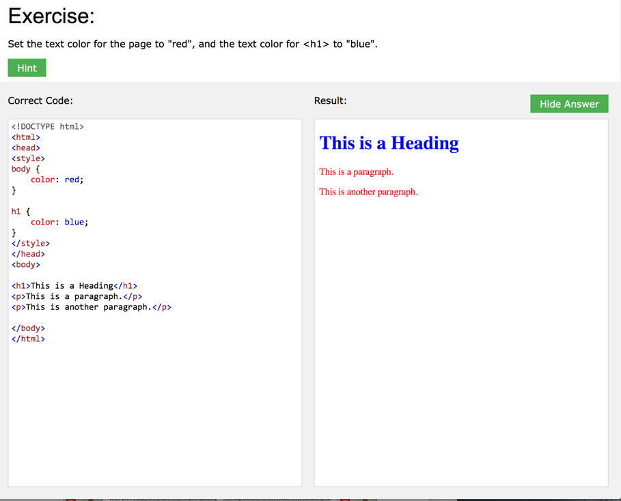Do exercises about css text at the end of the following w3schools page: <https://www.w3schools.com/css/css_text.asp>

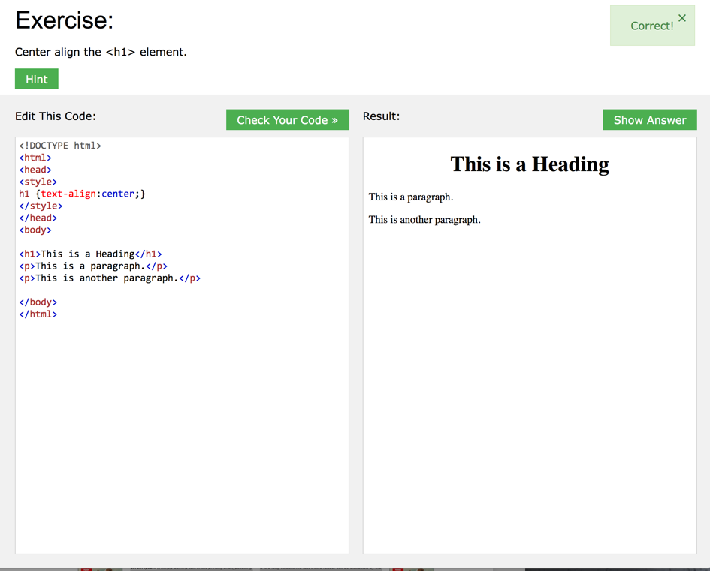

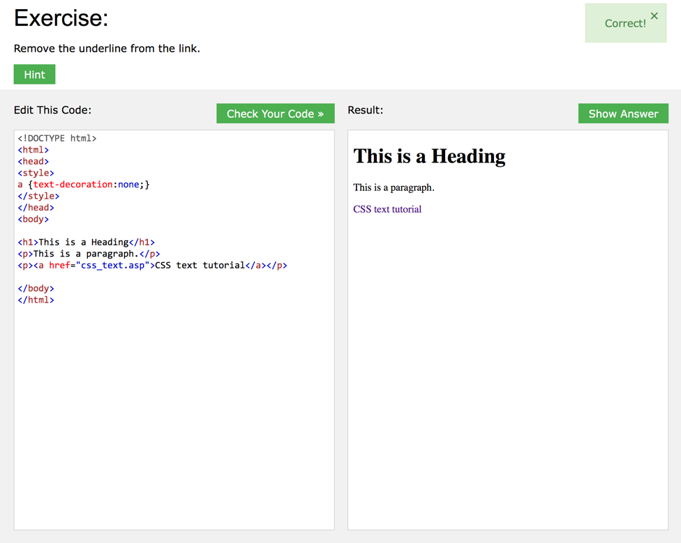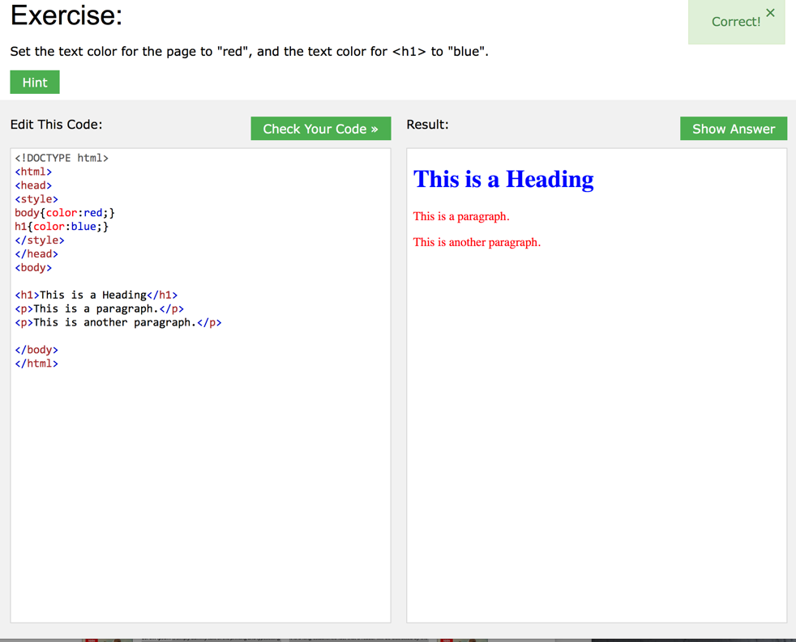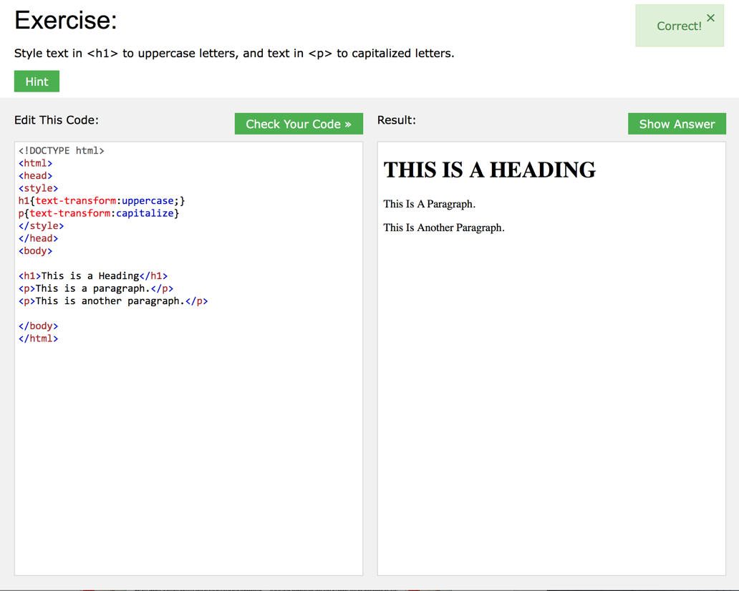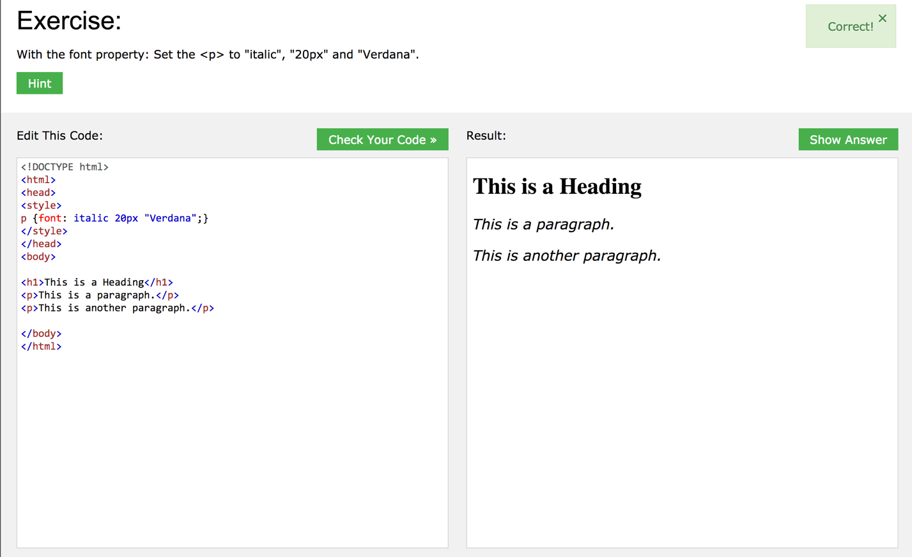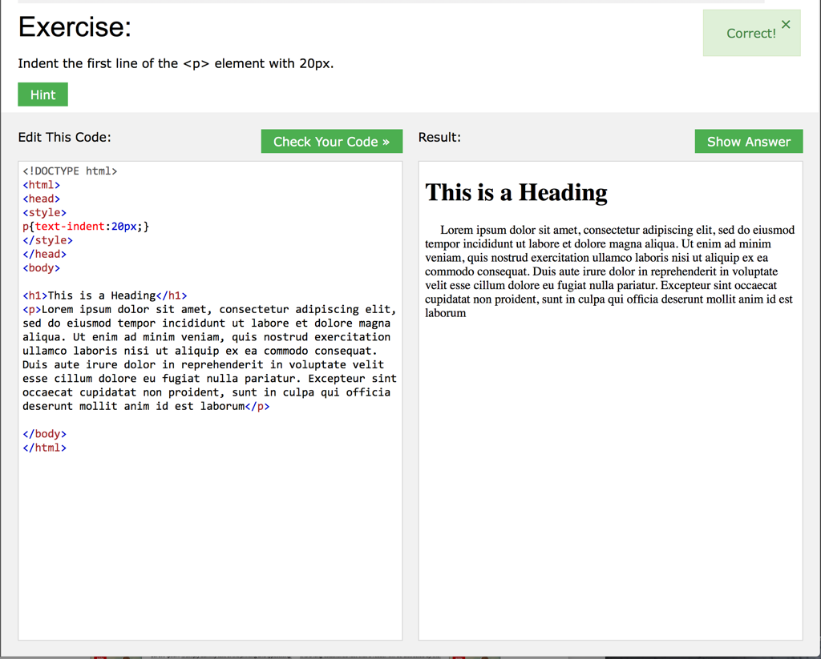

**CSS Fonts**

1. What are the two types of font family names? Arial, Georgia
2. What are three types of font generic families? What is
3. the difference between them? Serif(times, new roman, Georgia), sans-serif (arial, vendana, future), cursive (script), fantasy(critter), monospace (currier, fixedsys)
4. Which property is used to define the font family of a
5. text? Give an example in which the “times new roman” font-family: ”Arial”, sans-serif;
6. is preferred, then arial, then sans-serif.
7. Which property is used to change font size of a given
8. text? Font-size property What units can be used? Pixels or em What is the size unit
9. recommended by W3C? Why? Pixels
10. Which property is used to use italics style font? Font-style:italic;
11. Give an example of defining the font size of a
12. paragraph.

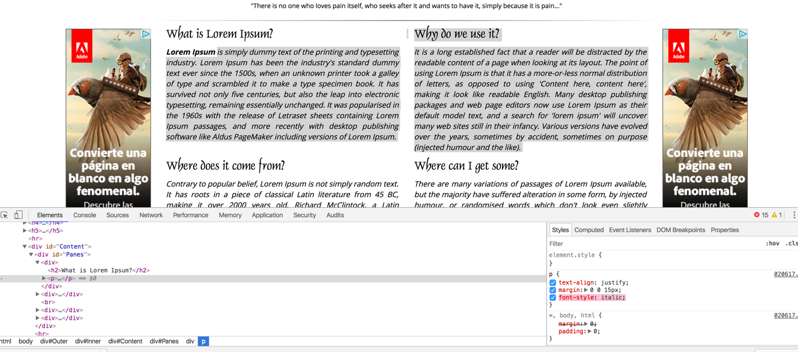

1. How can you define bold text? Give an example. Font-weight: bold;
2. Do exercises about css font at the end of the following
3. w3schools page:
4. https://www.w3schools.com/css/css_font.asp
5. Can you define several font properties in only one declaration? Explain
6. 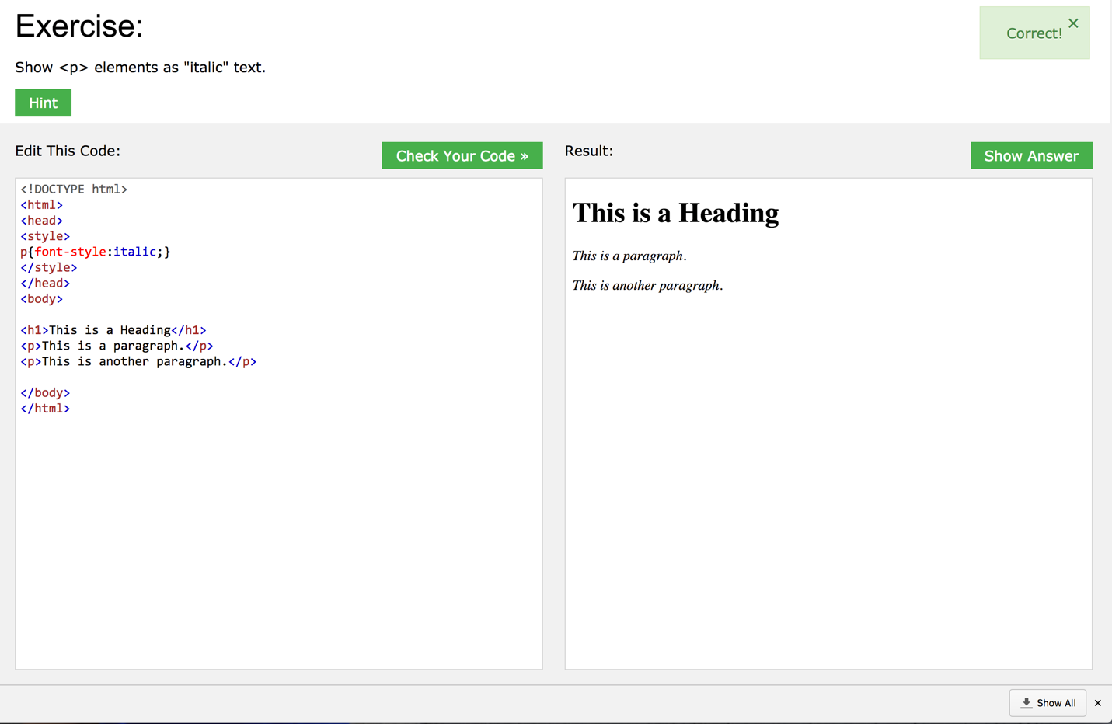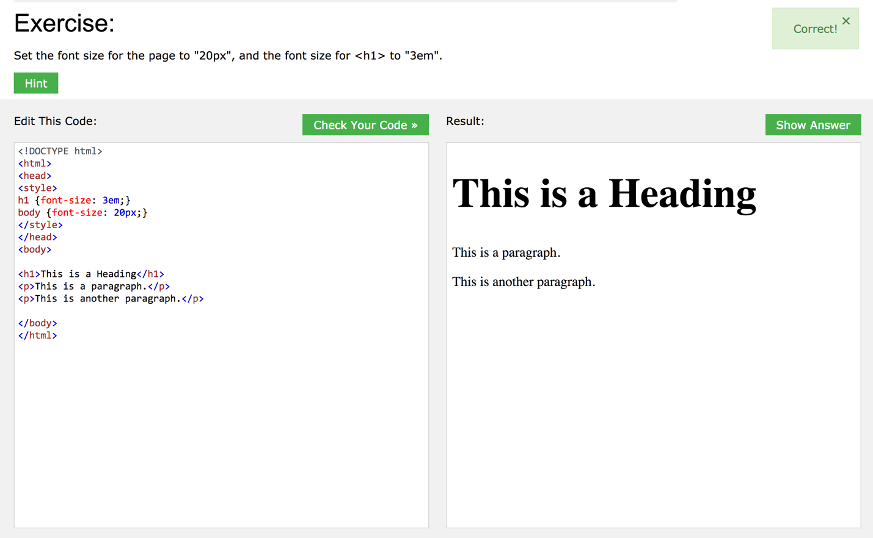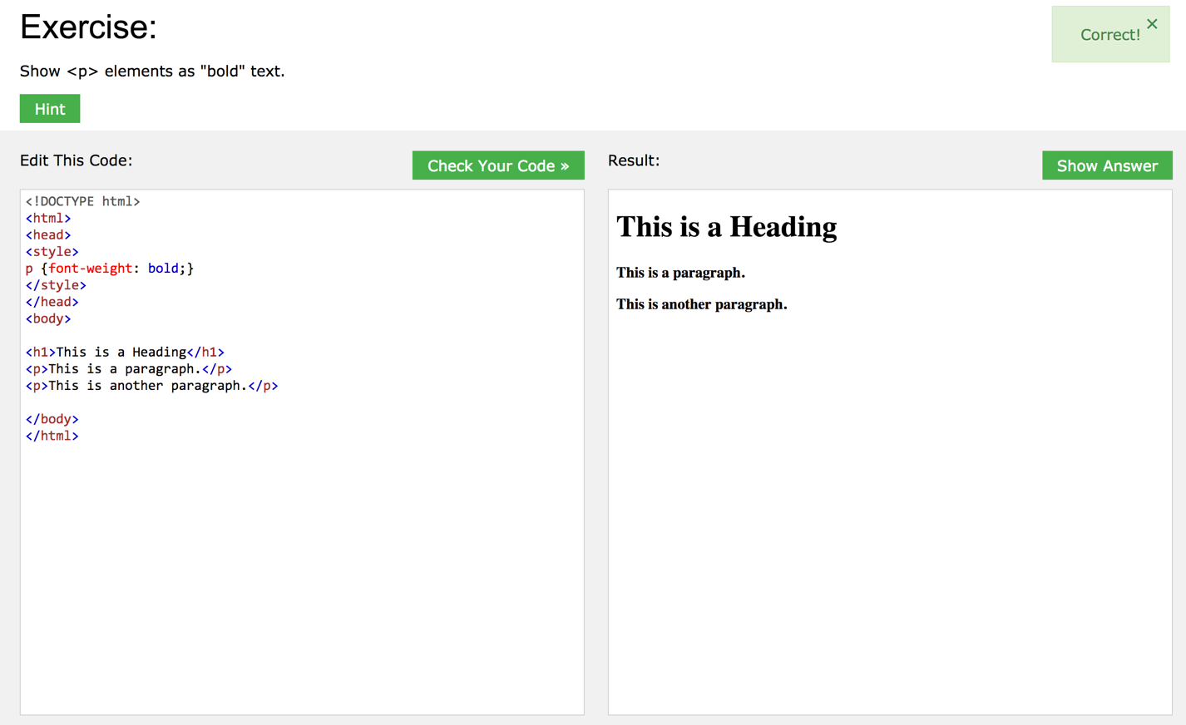

Yes you can, here is an example:

p.ex2 { font: italic bold 12px/30px Georgia, serif;}

**CSS**

1. What are pseudo-classes and a pseudo- elements? Pseudo classes: Special state of an element ( you write “:” and then the state eg. Focus, hover, active )

Pseudo-elements: Style specified parts of an element

What notation is used in each of them? Try some exercises in w3school page

1. Which css property is used to style lists? List-style-type property
2. Which properties are used to define the table border, width and height? Border: 1px solid pink;
3. Which properties are used to define the alignment, color in tables? Try 3 exercises formw3schools page. Align: center; text-align: center;
4. 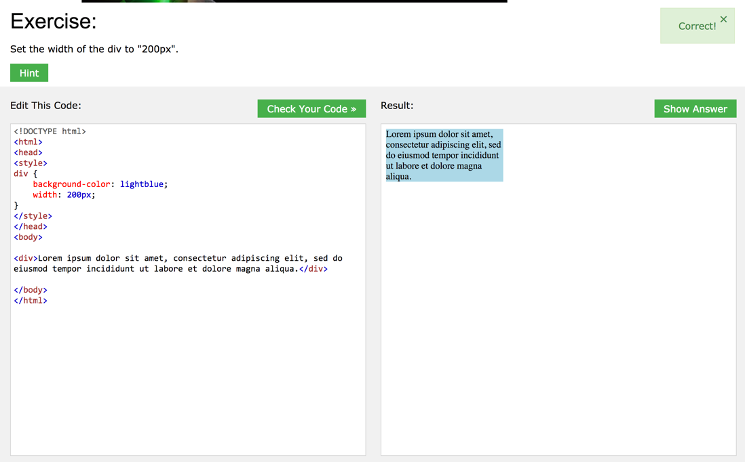What is a CSS box model? Describe it and do the 4 exercises in http://www.w3schools.com/css/css_boxmod